DAY 25 – 15.05.2024 – OUTPUT SCREENSHOTS

TO GET ALL CUSTOMERS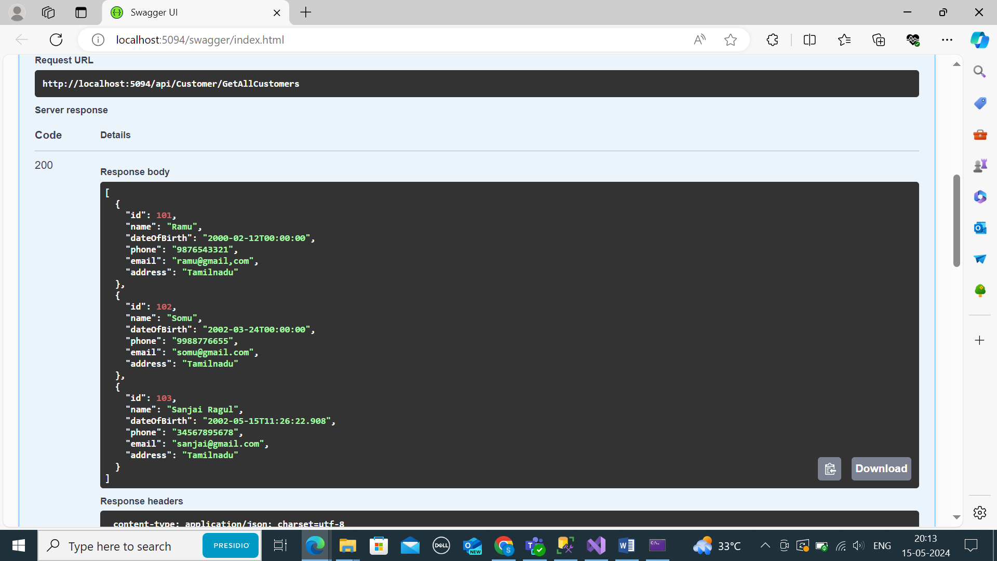

TO GET ADD PIZZAS

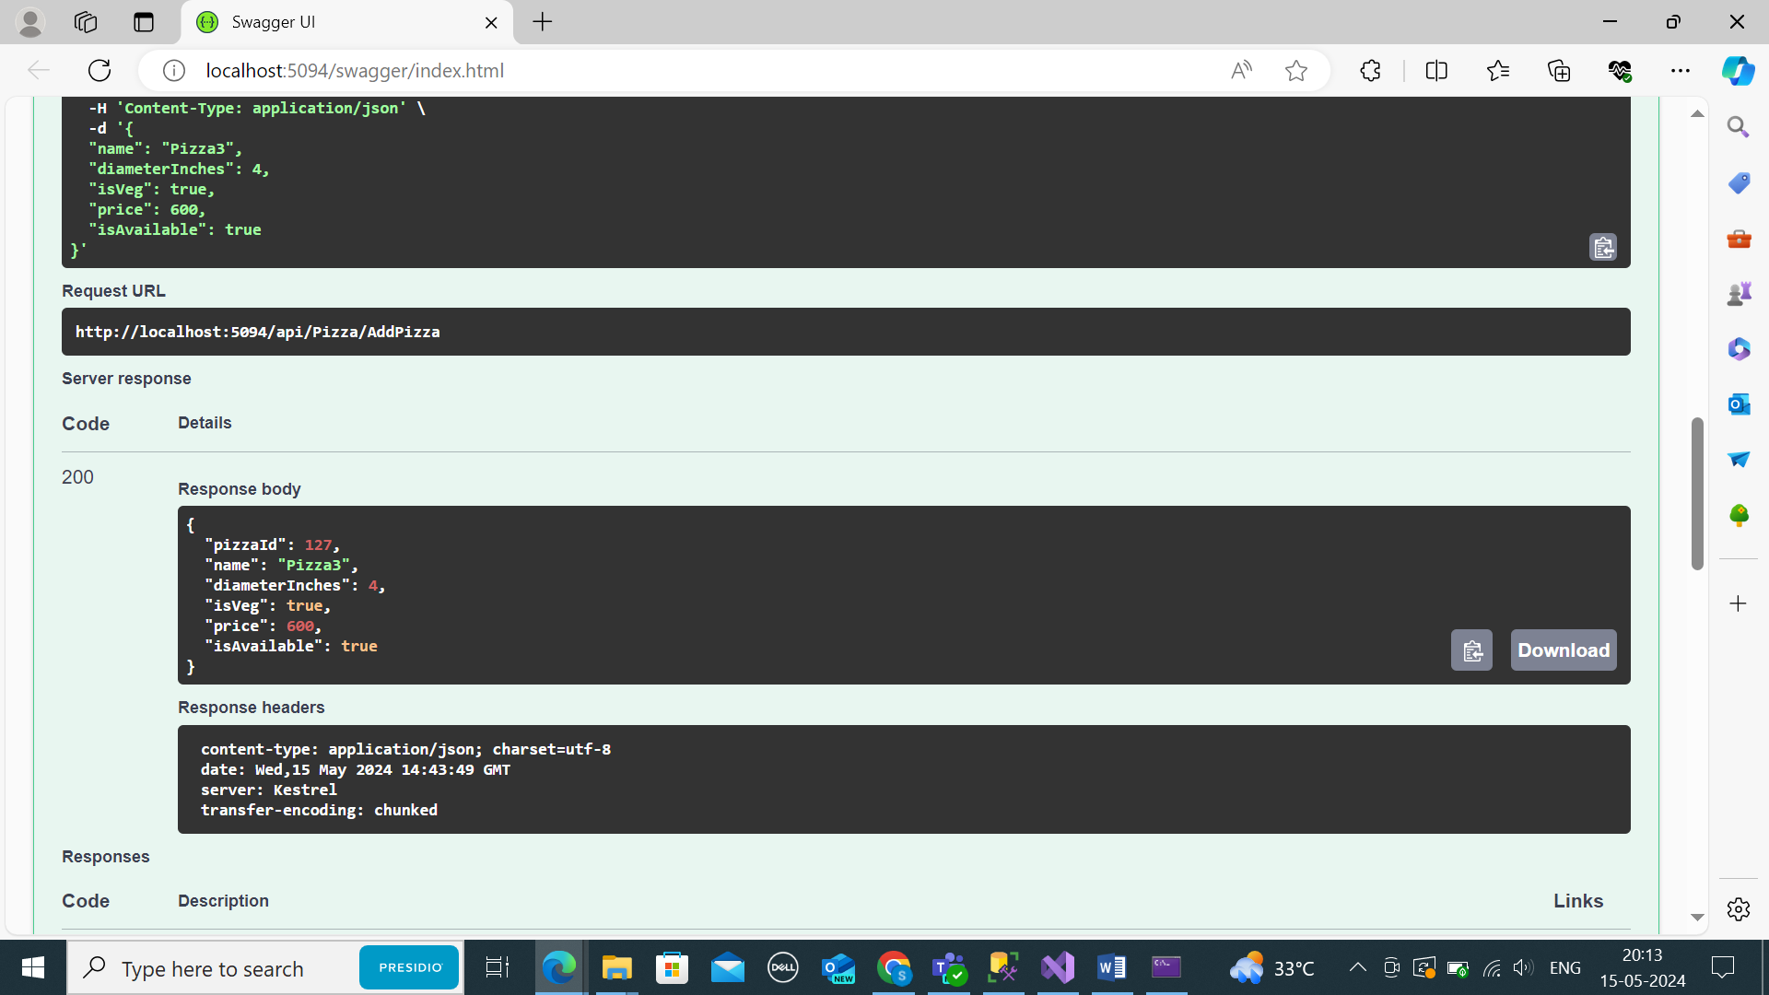

TO GET ALL AVAILABL PIZZAS

